Group 5

First Chance Saloon

Mary Cronin - 0510661

Adrian O Sullivan- 16230124

Deirdre Shanahan- 16230256

Cornelius Broderick - 9119124

# Introduction

This project will be to produce an online dating agency. The basic functionality should allow users to register and describe themselves, as well as browse other users and perform various searches (e.g. list all men over 25 who listed swimming as a hobby).

# High Level functionality

## User Stories

|  |  |  |  |
| --- | --- | --- | --- |
| *US001* | **User Profile** | *Priority* | **High** |
| *As A* | User | *Estimate* |  |
| *I would like* | To be able to register a user profile which includes a description of myself and indicating my preferences for a partner | | |
| *Because* | I am seeking a relationship with another person | | |
| *Acceptance Criteria* | * I can record the following details:   + Name   + Email   + Date of birth   + Sex   + Preferred Partner sex   + Password   + Location (nearest Town)   + Photo * I have the option of recording the following:   + Interests   + Hobbies   + Type of relationship   + Age profile of partner * User can only create a profile if they are over the age of 18 * Passwords are ranked in order of secureness * Only one profile per email address supported | | |

|  |  |  |  |
| --- | --- | --- | --- |
| *US001* | **Profile Matching List** | *Priority* | **High** |
| *As A* | User | *Estimate* |  |
| *I would like* | To be able to search for specific criteria | | |
| *Because* | I would like to be able to complete broad searches for potential partners | | |
| *Acceptance Criteria* | * I can complete searches based on sexual preference, age, hobbies or interests * I can find all potential matches based on criteria above * The information listed provides enough information to make an informed selection * I can sort the list by different headings | | |

|  |  |  |  |
| --- | --- | --- | --- |
| *US001* | **Profile Matching List** | *Priority* | **High** |
| *As A* | User | *Estimate* |  |
| *I would like* | To be able to see a list of people who are matched to my preferences with a scale showing their percentage match which includes location | | |
| *Because* | I would like to see a list of potential partners which is ranked based on my likes and location | | |
| *Acceptance Criteria* | * Based on my preferences I can see a list of matching potential partners * Location is included in the ranking with a high weighting * I can find people who are well suited to my preferences and interests * I can Like, Super Like (initiate request) or Goodbye profiles displayed * This list is presented to me when I log in. | | |

|  |  |  |  |
| --- | --- | --- | --- |
| *US001* | **Initiate Request** | *Priority* | **High** |
| *As A* | User | *Estimate* |  |
| *I would like* | Initiate “SuperLilke” meeting with a person listed on my match list | | |
| *Because* | I would like to be able to request a meeting with a potential match | | |
| *Acceptance Criteria* | * When I make a request to meet a person, I can see a limited set of details from their profile * When I make a request, that person can see a limited set of details from my profile * The request will expire after a number of days | | |

|  |  |  |  |
| --- | --- | --- | --- |
| *US001* | **Receive Request** | *Priority* | **High** |
| *As A* | User | *Estimate* |  |
| *I would like* | To be able to see a list of requests from other users | | |
| *Because* | I need to see potential partners who are interested in meeting me | | |
| *Acceptance Criteria* | * List of requests are visible and my match ranking is included * I can like , SuperLike or Goodbye or request additional information * When I receive a request, that person can see a limited set of details from my profile * If I accept a request, I can see more information on the user | | |

|  |  |  |  |
| --- | --- | --- | --- |
| *US001* | **Moderation** | *Priority* | **High** |
| *As A* | System Administrator | *Estimate* |  |
| *I would like* | To be able to oversee communications between users and block illegal or explicit content. | | |
| *Because* | The web site has a duty of care to their users | | |
| *Acceptance Criteria* | * A black list of words is maintained * Content containing black listed words is automatically blocked * The request will expire after a number of days * Option to report inappropriate content is available to users * Option to ban users from using the site | | |

|  |  |  |  |
| --- | --- | --- | --- |
| *US001* | **Moderation** | *Priority* | **High** |
| *As A* | User | *Estimate* |  |
| *I would like* | Notify the system administrator of inappropriate behaviour | | |
| *Because* | I would like to be protected from other user’s behaviour when I take offence | | |
| *Acceptance Criteria* | * A notification of bad behaviour can be initiated by the user * The user is notified of the actions taken by the administrator | | |

|  |  |  |  |
| --- | --- | --- | --- |
| *US001* | **Moderation** | *Priority* | **High** |
| *As A* | System Administrator | *Estimate* |  |
| *I would like* | Receive and process a notification of inappropriate behaviour from a user | | |
| *Because* | The web site has a duty of care to their users | | |
| *Acceptance Criteria* | * Users can be temporarily blocked from logging into the system for a period of time * User can be blocked from communicating with another specific user * User can be permanently blocked from using the system | | |

|  |  |  |  |
| --- | --- | --- | --- |
| *US001* | **Account destruction** | *Priority* | **High** |
| *As A* | User | *Estimate* |  |
| *I would like* | To be able to request that my account is removed from the system | | |
| *Because* | GDPR compliance | | |
| *Acceptance Criteria* | * User details including all communications from that user are removed from the system | | |

|  |  |  |  |
| --- | --- | --- | --- |
| *US001* | **Password reset** | *Priority* | **High** |
| *As A* | User | *Estimate* |  |
| *I would like* | To be able to reset my password | | |
| *Because* | I forgot my password | | |
| *Acceptance Criteria* | * Other users cannot reset my password | | |

|  |  |  |  |
| --- | --- | --- | --- |
| *US001* | **Security** | *Priority* | **High** |
| *As A* | System administrator | *Estimate* |  |
| *I would like* | To have security built into the website to prevent Denial of Service (Dos) and other forms of malicious code from being stored in the database | | |
| *Because* | I want to ensure availability of the website to our users | | |
| *Acceptance Criteria* | * SQL Injection attacks are blocked * Malicious code is prevented from being added to the database * Users cannot initiate any form on the site without first having a profile * Users must communicate using the HTTPS protocol (if this is possible using the UL site) | | |

## Data Flow Diagram

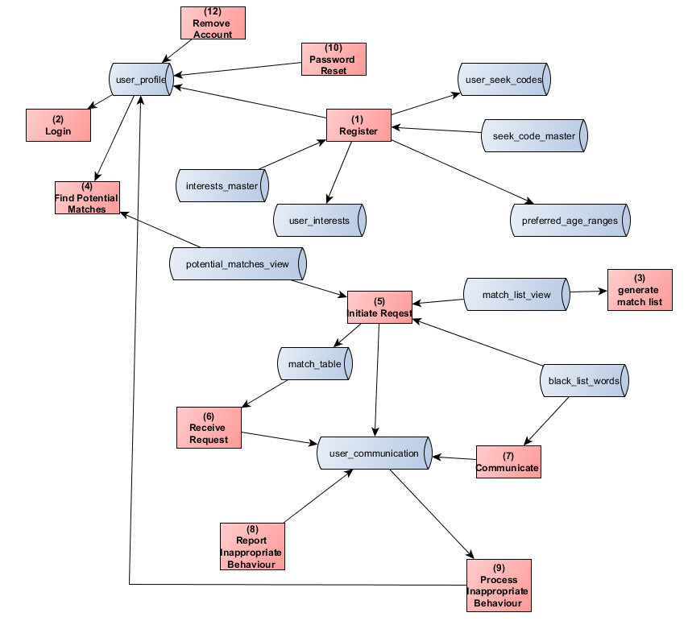

## Entity Relationship Diagram

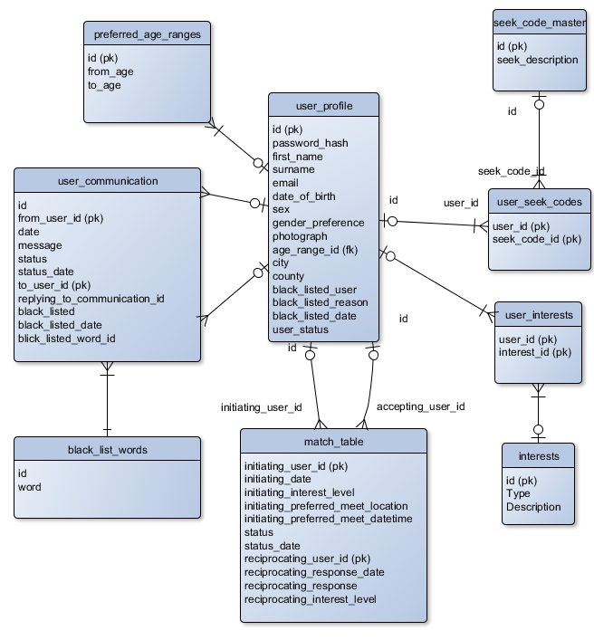

# Web Page Mock Ups

# Database Tables

Table 1 user_profile

|  |  |  |  |
| --- | --- | --- | --- |
| **Field** | **Type** | **Primary** | **Foreign** |
| id | int | Yes |  |
| password_hash | Varchar(200) |  |  |
| first_name | Varchar(50) |  |  |
| surname | Varchar(100) |  |  |
| email | Varchar(100) |  |  |
| date_of_birth | date |  |  |
| sex | bool |  |  |
| Gender_preference | Varchar(20) |  | yes |
| city | Varchar(100) |  |  |
| county | Varchar(100) |  |  |
| Black_listed_user | bool |  |  |
| Black_listed_reason | Varchar(100) |  |  |
| Black_listed_date | date |  |  |
| User_status | Varchar(50) |  |  |

Table2 match_table

|  |  |  |
| --- | --- | --- |
| **Field** | **Type** | **Primary** |
| Initiating_user_id | int | yes |
| Initiation_date | datetime |  |
| Initiation_interest_level | int |  |
| Initiation_prefered_meeting_location | Varchar(100) |  |
| Initiating_preferred_meet_datetime | datetime |  |
| status | Varchar(20) |  |
| Status_date | datetime |  |
| Reciprocating_user_id | int | yes |
| Reciprocatin_response_date | datetime |  |
| Reciprocating_response | Varchar(2000) |  |
| Reciprocating_interest_level | int |  |

Table 3 user_communication

|  |  |  |
| --- | --- | --- |
| **Field** | **Type** | **Primary** |
| id | int |  |
| from_user_id | int | yes |
| date | datetime |  |
| message | Varchar(150) |  |
| status | Varchar(20) |  |
| To_user_id | int |  |
| Replying_to_communication_id | int |  |
| Black_listed | bool |  |
| Black_listed_date | datetime |  |
| Black_listed_word_id | int |  |

Table 4 perferred_age_ranges

|  |  |  |
| --- | --- | --- |
| **Field** | **Type** | **Primary** |
| id | int | yes |
| From_age | int |  |
| to_age | int |  |

Table 5 black _list_words

|  |  |  |
| --- | --- | --- |
| **Field** | **Type** | **Primary** |
| id | int | yes |
| word | Varchar(100) |  |

Table 6 user_seek_code

|  |  |  |
| --- | --- | --- |
| **Field** | **Type** | **Primary** |
| User_id | int | yes |
| Seek_code_id | int |  |

Table 7 seek_code_master

|  |  |  |
| --- | --- | --- |
| **Field** | **Type** | **Primary** |
| id |  | yes |
| Seek_description |  |  |

Table 8 user_interests

|  |  |  |
| --- | --- | --- |
| **Field** | **Type** | **Primary** |
| User_id | int | yes |
| Interest_id | int | yes |

Table 9 interests

|  |  |  |
| --- | --- | --- |
| **Field** | **Type** | **Primary** |
| id | int | yes |
| type | Varchar(100) |  |
| description | Varchar(200) |  |

# Process List